Welcome to Study Service Business Management!
Information on Education, Degree Structure and Competence Assessment
Group: HMA221SN

Content

LAUREA'S MISSION 3
COMPETENCE DEVELOPMENT 3
LEARNING BY DEVELOPING (LbD) 4
DEGREE STRUCTURE 5
Scope and Extent of the Degree 5
Degree Structure 5
DEGREE REQUIREMENTS 6
Degree requirements regarding core competence 6
Degree requirements regarding complementary competence 7
FLEXIBLE POSSIBILITIES FOR COMPLETING ATTAINMENTS AND SPECIALISING 8
ASSESSMENT OF LEARNING AND COMPETENCE IN THE BACHELOR’S DEGREE PROGRAMME 8
INTERNATIONAL COMPARABILITY OF THE DEGREE 12
CURRICULUM DEVELOPMENT 12

The purpose of this attachment to the curriculum is to provide you with basic information on the operating methods, degree structure and requirements as well as the assessment of competence and learning at Laurea and in the education. If you have additional questions, please contact your personal tutor or peer tutor.

Wishing you success in your studies!

Katri Ojasalo
Vice President (Education)

LAUREA'S MISSION
Laurea is a student-centred, international, inspiring and innovative university of applied sciences. Our mission is to educate, research, develop and innovate. In our activities we apply the action model of Learning by Developing (LbD).

As a student you will encounter authentic workplace actors and your competence will be challenged during their studies. A student graduating from Laurea will be able to act in new situations, anticipate future trends, develop new operating models and examine the world with open eyes. Laurea's mission is to be an internationally networked university of applied sciences with an operating method that creates links between learning and the working life. This way, new competence will be produced and service innovations generated.

COMPETENCE DEVELOPMENT
At Laurea our focus is on the student, which emphasize your freedom and responsibility. You are offered an opportunity to develop your competence to meet your own professional goals. Freedom means that the learning outcomes may be achieved through different modes of studying. Responsibility means an active approach to studying, responsibility for your own choices and a constructive and motivated attitude towards doing things together. Laurea's staff is responsible for supporting and guiding your professional growth.

Internationality at Laurea means numerous opportunities for being active in various multicultural settings, developing your language skills, going on student exchanges and taking part in international research and development (R&D) projects.

Student entrepreneurship is supported and entrepreneurship is visible in Laurea's activities not only as an entrepreneurial attitude and cooperation with companies but also as concrete new businesses that our students may set up even before completing their studies.

Laurea produces experts for the future who can develop their own work, are professionally committed and have capabilities for serving in expert tasks in their own fields.

The education aims for an extensive and strong professional competence. Workplace driven projects also develop generic working life competences (see picture 1). The graduates will have capabilities for following and promoting the development of their professional fields and for continuous improvement of their personal professional competence. The education imparts the students adequate communication and linguistic skills for tasks in their fields as well as for international activities and cooperation.
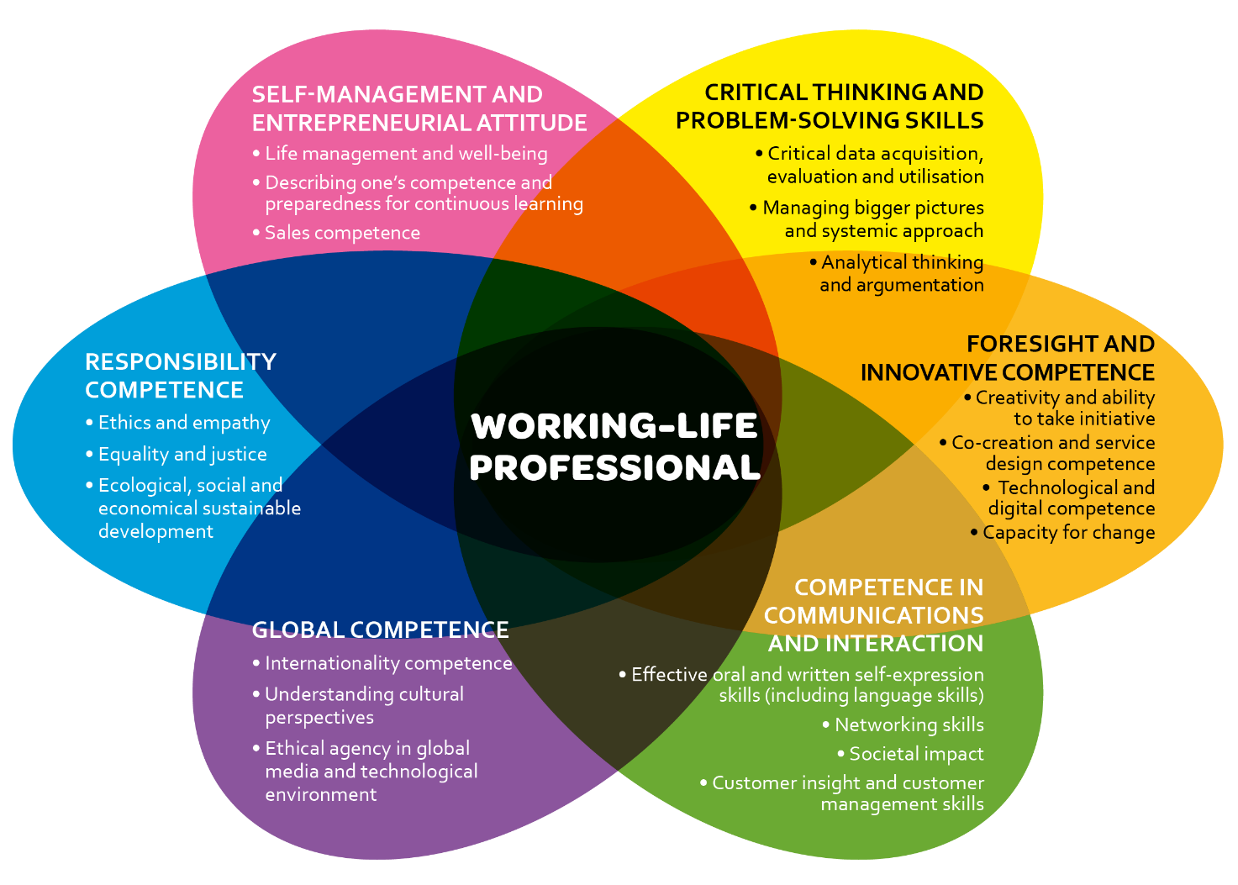
Picture 1. Generic working-life competences common for all degree programmes.

LEARNING BY DEVELOPING (LbD)
Laurea's inspiring and innovative learning environments are based on the model of Learning by Developing. The idea of Learning by Developing is built around authentic encounters with the working life. The ensuing cooperation is based on trust and creativity.

As a student you will learn to identify targets for workplace and competence development, to create new solutions, products and operating models and to develop your own action in observance of changing workplace requirements. The typical characteristics of LbD include authenticity, partnership, experiential nature, creativity and a research-oriented approach.

Learning by Developing combines learning that produces competence with creativity through various research and development projects. Learning builds on new opportunities that open up as the project progresses. The required competence is accumulated through practical activities in various workshops.

DEGREE STRUCTURE

Scope and Extent of the Degree
The scope of a Bachelor's degree in Service Business Management is 210 credits. It takes on average 3.5 years to complete.
In line with the international ECTS standard, one credit corresponds with 26.7 hours of work for an average student. In order to graduate in the targeted time, you should earn an average of 30 credits per semester.

Degree Structure
The degree studies at Laurea consists of core competence and complementary competence modules. The modules comprise competence areas that are part of the degree.
Core competence modules impart competence that is part of the degree's compulsory requirements. The scope of core competence modules is 30 credits. The modules contain the following types of studies: basic studies, professional studies, practical studies and a Bachelor's thesis.
Complementary competence modules support individual study paths and competence and make it possible to deepen or extend your knowledge. The modules can mainly be freely selected. You can include in your degree complementary competence modules that are compatible with your professional goals. The compatibility of the elective studies with your degree will be subject to prior agreement with your teacher tutor.
Learning is made relevant to workplace development and the your personal goals. Learning outcomes have been defined for the modules on the basis of workplace needs as well as the future needs emerging from studies and surveys.
In practice, credits are attained when you complete study units that are part of the module or engage in projects in which the corresponding competence area is develop (see picture 2). Credits can also be gained through recognition of prior learning or demonstrations.
Studies can be implemented either in Finnish or in English. The language of the implementation is decided for each semester and is visible in the study unit or project implementation plan.
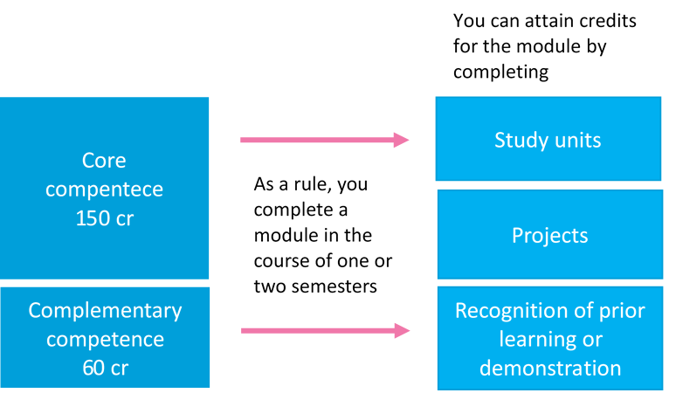
Picture 2. Accumulation of studies in the degree structure

DEGREE REQUIREMENTS
The learning outcomes of the core competence modules describe the required competence that the you must achieve in order to complete the degree. The degree requirements include language studies, which are to be completed, according to instructions, as part of the core competence studies. Finnish Students are also required to demonstrate their proficiency in both national languages (Finnish and Swedish) and in English, as part of the core competence of the degree. In addition, Finnish students must obtain the proficiency in the second national language (Swedish or Finnish) required of personnel in the service of public bodies. Apart from the core competence modules, you must complete complementary studies to reach the required scope of the degree.

Degree Requirements Regarding Core Competence
The scope of core competence is 150 credits. The following learning outcomes have been specified for core competence in each module:
- Business Operations (30 cr)

During the module, interactive skills and competences in business, entrepreneurship and project work are developed.

After completing the module, students are able to recognize and evaluate opportunities in the business environment, and analyze and assess the prerequisites for successful business. Students know how to act in an entrepreneurial and customer-oriented manner. They are able to work in projects, create networks and engage in cooperation with both Finnish and international partners. Students also achieve the level of competence in the other national language required from public servants or reach the target level of A1.1 in the Common European Framework of Reference for Languages.
- Business Development (30 cr)

The objective of the module is to enable students to identify the needs of customers and develop customer-oriented products, and to enhance students’ organizational and decision-making competence in the business field.

After completing the module, students are able to launch and implement business activities innovatively and responsibly and can develop products and services in a customer-oriented manner. They are able to generate and utilize financial information to support decision-making, plan and implement marketing activities, and acquire, develop and manage customer relationships. Students are able to assess, develop and manage their own and their organization's activities as participants and leaders in multicultural work communities and to apply principles of effective communication in English in work-related situations.

- Sustainability and Business Analysis (30 cr)

During the module student´s competence in service business is strengthened. After completing the module student is able to create value for customers in service business. Student is able to use various tools in service design and digital marketing. Student is able to advance sustainability, corporate responsibility and circular business in organizations. Student is able to make business decisions based on data.

- Expert in a Work Community (30 cr)

During the module, students deepen their expertise in their chosen field. They learn how to apply for jobs that support their career plan and to act responsibly in national and international positions requiring professional expertise. Students develop the capacity to develop the activities of the organisation and their own expertise.

- Expert in Development and Workplace Innovation (30 cr)

The objective of the module is to develop the students’ abilities to study individually and in teams, to prepare to carry out research and development work, and to support career development and the creation of a work identity. At the beginning of their studies students acquire familiarity with the tools required in higher education and the operating methods of development-based learning.

After completing the module, students are able to work responsibly both independently and as team members. They are able to assess and develop themselves as learners and are capable of identifying development targets in the workplace.

Students are able to plan, implement and evaluate a project in cooperation with different networks in the workplace. They are able to employ appropriate research methods and the methods of development activities and project work. Students are able to identify creative and innovative solutions for the challenges of workplace development.

Students able to report the results of their development work using a style of writing characteristic of research. Students are able to plan their studies, development and career with an eye on the development prospects of their own field.

Degree Requirements Regarding Complementary Competence
The rest of the degree (60 cr) consists of elective complementary competence studies.
At Laurea we encourage you to take part in voluntary work during your studies. The objective is that everyone develops their professional competences during their studies by participating in voluntary work in a role they choose themselves. You can fit voluntary work into any stage of your studies and gain credits.

FLEXIBLE POSSIBILITIES FOR COMPLETING ATTAINMENTS AND SPECIALISING
At Laurea, you have flexible possibilities of building up the competence specified in the modules' learning outcomes. Among other things, you can
- choose core competence studies offered by Laurea’s various campuses under modules of the same name, provided that there is space in the group,
- select complementary competence modules that support your professional goals in Laurea's various campuses,
- select Finnish studies from Laurea's offer of Finnish education, even if you are studying in an English education,
- select online studies that give you more flexibility in your study schedules,
- develop your competence by taking part in projects,
- exhibit your proficiency in demonstrations or utilize work-based learning,
- choose options available for cross-studies, which are offered, for example, by Laurea, Haaga-Helia and Metropolia (3AMK) and Aalto University as well as
- take part in student exchange.
The study unit and project implementation plan include the actual start and end dates of the studies, the implementing campus, language of instruction, registration period, number of credits, learning outcomes, evaluation criteria and areas, implementation methods, degree workload and mandatory literature. The learning outcomes, schedule and evaluation criteria are reviewed together with the students at the beginning of each study unit.
You can target your competence by means of selecting complementary competence modules, participating in various projects and when choosing your placements and the theme of your thesis. Career guidance will be provided to support your study path.

ASSESSMENT OF LEARNING AND COMPETENCE IN THE BACHELOR’S DEGREE PROGRAMME
In the curriculum, the learning outcomes are described as the learner's actions, so that the development of competence can be assessed with reference to the set goals. Competence is identified as knowledge, skills and values related competence as well as experiential competence that includes the competence of an individual and a community. The competence descriptions in the curriculum draw on Bloom's taxonomy, where the development of competence is described at six different levels: knowledge, comprehension, application, analysis, synthesis and evaluation/creativity.

Assessment of Studies

Study units and projects are graded as follows:
5 (Excellent),
4 (Good),
3 (Good),
2 (Satisfactory),
1 (Satisfactory) and
Fail (HYL).

Some study units or parts can also be graded simply as Pass (HYV) or Fail (HYL).
Framework for Assessment
The competences are always assessed by using the criteria in force at the time in question. The criteria can be changed during the studies. The basis of assessment described below were valid when the curriculum for your degree programme was published.
The assessment framework includes two requirement levels, Level I and Level II (see table 1 and 2). A requirement level, outlining the criteria used for assessment, has been defined for each study unit. The specific competence criteria (according to level I or II) are described in the implementation plan of each study unit/project. The assessment criteria serve as benchmarks for assessing the qualitative achievement of the learning outcomes indicated in the curriculum.
Within the requirement levels of the assessment framework, the required competence is described for levels Pass/1, 3 and 5. The competence acquired by students is assessed comprehensively. For good competence (3), it is required to also meet the criteria for satisfactory competence. Similarly, for excellent competence (5), the assessment criteria for satisfactory and good competence must also be met. If the criteria for good competence are not fully met but all the criteria for a satisfactory level are met, the grade will be 2. Similarly, your grade will be 4 if the competence level is good but still not excellent in all respects.

The following criteria apply to all studies except the thesis, which is assessed according to a set of specific criteria expressed in the thesis guidelines. The assessment criteria are based on the European (EQF) and national (NQF) qualifications frameworks.

Table 1. Framework for assessing the competence of bachelor students: requirement level I

 | PROFESSIONAL KNOWLEDGE BASIS, INFORMATION SEARCHING AND REPORTING | PROFESSIONAL PRACTICE AND WORKPLACE DEVELOPMENT | Assessed as applicable: TEAMWORK SKILLS, LEADERSHIP AND RESPONSIBILITY
Grade 5 The student is able to… | - use professional concepts extensively  - compare and choose  - relevant information  - report and communicate in a professional manner | - work independently, using the skills and methods learned  - take responsibility for interaction with customers and/or co-operation partners and for responding to their needs  - anticipate his/her need for guidance | - promote the team’s work and team spirit  - manage his/her time appropriately, completing the agreed tasks at the required quality level  - work responsibly, applying the skills and methods learned  - plan and evaluate their work, taking safety and/or ethical aspects into consideration
Grade 3  The student is able to… | - use professional concepts in a consistent manner when explaining various work practices and situations  - gather information and use his/her knowledge basis  report in the agreed manner | - work using the skills and methods learned  - engage in professional interaction with customers and/or co-operation partners and identify their needs  - take part in guidance and utilise it | - engage in goal-oriented work in a team  - plan and manage the progress of his/her work and use of time  - detect safety-related risks  - justify this/her actions in accordance with the professional code of conduct
Grade pass/1 The student is able to…. | - use essential professional concepts when explaining various work practices and situations  - search for information in different sources  - report | - work under guidance using the skills and methods learned  - interact with customers and/or co-operation partners  - receive guidance | - work as a member of a team  - plan the progress of his/her work and use of time under guidance  - work safely and in accordance with the professional code of conduct  - follow the provided instructions and rules

Table 2. Framework for assessing the competence of bachelor students: requirement level II

 | PROFESSIONAL KNOWLEDGE BASIS, INFORMATION SEARCHING AND REPORTING | PROFESSIONAL PRACTICE AND WORKPLACE DEVELOPMENT | Assessed as applicable: TEAMWORK SKILLS, LEADERSHIP AND RESPONSIBILITY
Grade 5  The student is able to… | - analyse the acquired information, draw conclusions and combine theoretical knowledge with experiential knowledge | - evaluate the applicability of produced knowledge, skill or idea to other contexts as well as their impact  - anticipate needs of customers and/or co-operation partners | - evaluate and develop the team’s entrepreneurial and responsible approach to work  - evaluate the possibilities for utilising competence and plan his/her personal development and development of the team
Grade 3  The student is able to… | - critically evaluate information and justify their actions with science-based knowledge | - propose creative solutions at work  - promote professional co-operation and enhance customer and partner relationships | - act in a manner that promotes the team’s entrepreneurial and responsible approach to work  - describe the development of his/her competence in relation to the learning outcomes
Grade pass/1  The student is able to… | - use professional concepts in a consistent manner and demonstrate his/her familiarity with the knowledge basis  - report and communicate in a professional manner | - act independently taking into account the operating environment  - take responsibility for interaction with customers and/or co-operation partners and for responding to their needs | - describe the significance of his/her actions for successful co-operation  - describe his/her competence in relation to the learning outcomes

The assessments draw on the students' self and peer assessments and the assessments of employer representatives. Assessment helps you to monitor the development of your competence and the achievement of your personal goals in relation to the competence requirements set for the degree.

INTERNATIONAL COMPARABILITY OF THE DEGREE
The level of the degree corresponds with level 6 of the National Qualifications Framework (NQF) and level 6 of the European Qualifications Framework (EQF).
In the curriculum, the learning outcomes of a study unit are described for level 3, good skills, on the assessment scale (1-5).

CURRICULUM DEVELOPMENT
The curriculum is developed by using evaluation, monitoring and feedback data. Feedback is received from students, personnel and workplaces for the development of the curriculum. In addition, the curriculum is regularly assessed using predefined assessment criteria. The development of the curriculum also takes into consideration the changing needs of society.
Changes may occur in the study units and implementation modes of the modules. Especially the offering of the complementary competence modules is constantly under development to match the requirements of the working life and thus the offering may change during the studies.
In parallel to curriculum changes, Laurea also works to continuously develop the study implementations. Self-assessment of studies by means of education quality criteria is incorporated in the planning of each implementation.

